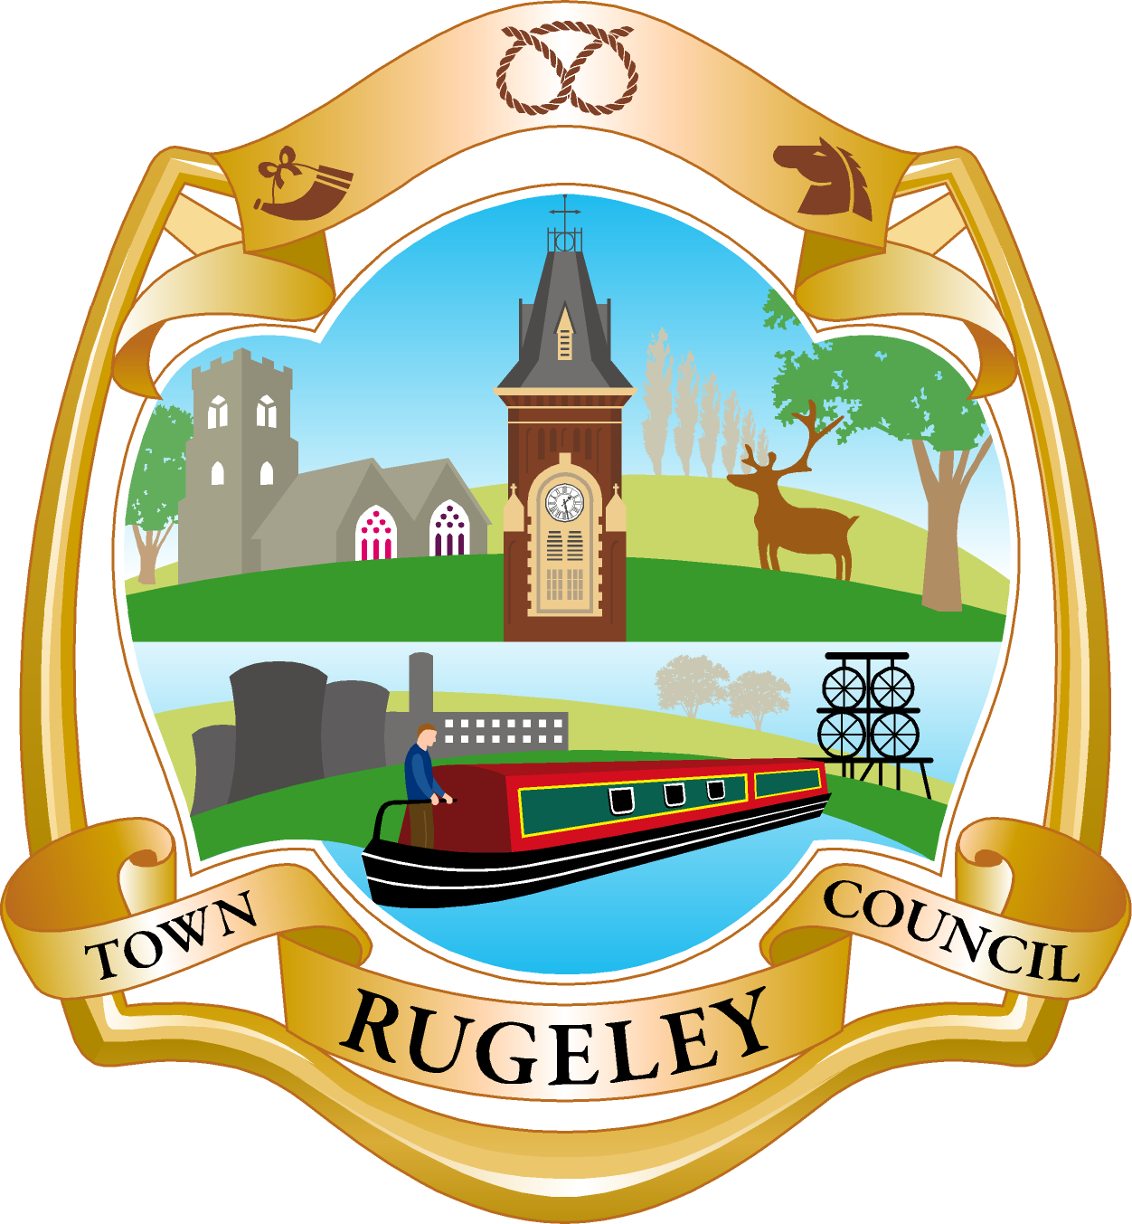

Rugeley Town Council

Minutes of the Community Engagement Committee held online via Zoom
at 7.30pm Wednesday 14th October 2020.

PRESENT: Councillors: P. Ansell A. Cooney
G. Grant C. Green (Vice Chair)
I. Gunner I. Hodgson (Chair)
O. Lyons N. Mahon
A. Szklarczyk

ALSO PRESENT: H Goodreid – Town Clerk

Min No | Item | Action
17  17.1 | Apologies  All Councillors were in attendance.
18  18.1 | Declarations of Interest  Declarations of interest were made by Cllr Hodgson, Green and Cooney in item 25 and 27 as they were traders in the town and / or members of the Rugeley Lottery Committee. Dispensation was requested in order to allow them to speak on these items.  Proposed: Cllr Mahon; Seocnded: Cllr Lyons  It was agreed that Cllrs Hodgson, Green and Cooney be allowed to contribute to the discussion on items 25 and 27.
19  19.1 | Chair to close the meeting for the public session  No members of the public were in attendance.
20 | Chair to reopen meeting
21  21.1 | Minutes  The Minutes of the Community Engagement Committee held on 9th September 2020 were approved as a true and accurate record.  Proposed: Cllr Szklarczyk; Seconded: Cllr Mahon  It was agreed that the minutes of 9th September 2020 be approved.
22  22.1 | Matters Arising from the Minutes  All matters arising were either complete or on the agenda for the meeting.

23  23.1  23.2  23.3 | Remembrance Events  The Clerk updated Cllrs on conversations held with Richard Bates from the Rugeley branch of the Royal British Legion and with Father David from St Augustines Church. Cllrs agreed that to encourage the community to attend a Remembrance Service at the memorial would be against current government guidance on social distancing.  It was proposed that the Town Council attend a local church service if invited to do so but would not attend a parade / service at the memorial. It was further proposed that a wreath would be lain at the memorial by the Town Council which would be filmed and posted on Facebook / website on the 11th November. Cllr Gunner offered to create the film to be shown.  Proposed; Cllr Mahon; Seconded: Cllr Lyoons  It was agreed that the Town Council would attend a local church service on 8th November but would lay a wreath at the memorial at a different time which would be filmed and broadcast.  Cllr Lyons advised that a Remembrance display would be going up at Elmore Park.  It was proposed that funding be found to purchase RBL CD’s for the local care homes with a floral tribute as well. Cllr Ansell offered to pay for this from her Chairs Allowance.  Proposed: Cllr Hodgson; Seconded: Cllr Lyons  It was agreed that the Chairs Allowance be used to purchase RBL CD’s for the local care homes with a floral tribute as well. | Cllr Gunner to prepare a film of wreath laying by the Town Council for release on 11th November 2020.  Clerk to arrange purchase and distribution of the RBL Remembrance CD’s and floral tributes.
24  24.1 | Finances  Cllrs considered the latest finance figures for their budget. It was noted that the final instalment for this years Christmas lights would be paid in January once they had been removed.
25  25.1  25.2  25.3 | ShopAppy and Totally Locally  The Clerk gave an update on the free ShopAppy initiative for local Rugeley traders. There had been a poor uptake to date and a push needed to be made to encourage local traders to benefit from this scheme.  Cllr Mahon reported on the Totally Locally Fiver Fest which would operate between 10th and 24th October - 41 shops were already signed up for this.  Cllr Cooney and Green spoke about the Rugeley Lotto Events Christmas Sparkle virtual market place which would operate through Christmas season.
26  26.1 | Update on Development Officer post  Second interviews were to be held and it was hoped a decision would be made then. It was noted that the role would come under the umbrella of the Community Engagement Committee. It was suggested that an extraordinary meeting of the Community Engagement Committee be held to introduce the new candidate to the committee if they were available, and to talk about project ideas. | Clerk to set up extraordinary meeting.
27  27.1  27.2 | Christmas Events  The possibility of live streaming the Christmas Light Switch on was discussed. It was proposed that we encourage residents to put their own Christmas lights on their houses on the same day as the lights switch on and if they took pictures, we could develop a small looping film mintage of all the Christmas lights around Rugeley and post on Facebook and Social Media.  Proposed; Cllr Hodgson; Cllr Cooney  It was agreed that the Christmas Light switch on is filmed and broadcast on social media. Residents would be asked to switch on their own lights on the same day, take photos and Cllr Gunner would make a montage of this which would be shared on social media / on the website.  Rugeley Lotto Events would be hosting Santa for 3 or 4 nights in the week of the 7th – 12th December at Rugeley Rose Theatre. Tickets would be free of charge but would allow for socially distance bubbles to come in to see Santa. A request was made for spare artificial trees which would be borrowed to create a magical walkway through the theatre to Santa. A local choir was to be approached to see if they would be willing to sing while people were queuing. | Cllr Gunner and Town Clerk to work on this project.
28  28.1 | Date of Next Meeting  Extraordinary Meeting of Community Engagement Committee at 7.30pm on Wednesday 28th October  Community Engagement Committee would be held on Wednesday 11th November 2020 at 7.30pm.
The meeting closed at 9.00pm

