Rugeley Fringe Festival Application Form

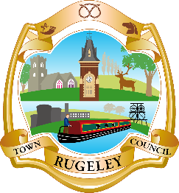

Please complete the form and send it through to Rugeley Town Council. If selected, you’ll get to perform in front of hundreds of keen Fringe goers and will get a feature in our Fringe Festival programme. In addition, you will get social media exposure to thousands in and around the local area and free entry to the festival.

GENERAL INFORMATION

Show/Workshop Title:
Company/Artist Name:
Social Media Handles/Website Address:
Main Contact Name:
Email Address:
Contact Number:

SHOW/WORKSHOP INFORMATION

Show/Workshop Description:
Running Time:
Maximum Participants/Audience Size:
Any Age Restrictions?
Do you have any technical requirements from the venue?
Yes No
If yes, please detail below:

Are you bringing any of your own equipment?
Yes No
If yes, please detail below:

Do you need a member of our team to help you set up?
Yes No If yes, in what capacity?
Do you have your own Public Liability Insurance?
(If yes, we ask that you provide us with a copy for our records)
Yes No

AVAILABILITY

The event will take place on Saturday 23rd May, Sunday 24th May and Monday 25th May 2020, please let us know what times you are available on these dates (please tick all times you are available):
Saturday 23rd May
11am – 12pm
12pm – 1pm
1pm – 2pm
2pm – 3pm
3pm – 4pm
4pm – 5pm

Sunday 24th May
11am – 12pm
12pm – 1pm 5pm – 6pm
1pm – 2pm 6pm – 7pm
2pm – 3pm 7pm – 8pm
3pm – 4pm 8pm – 9pm
4pm – 5pm 9pm – 10pm

Monday 25th May
11am – 12pm
12pm – 1pm
1pm – 2pm
2pm – 3pm
3pm – 4pm
4pm – 5pm

OTHER INFORMATION

If there is any further information you need to provide, please do so below:

Please return this information to us as soon as possible to clerk@rugeleytowncouncil.gov.uk or Rugeley Town Council, Taylors Lane, Rugeley, Staffordshire, WS15 2AA along with any promotional materials you are happy for us to use on our social media pages.

