LOCAL GOVERNMENT ACT 1972 - NOTICE IS HEREBY GIVEN THAT THE ANNUAL PARISH ASSEMBLY WILL BE HELD:

Rugeley Rose Theatre, Taylors Lane, Rugeley, WS15 2AA

on Wednesday 23rd May.

The public display of information and refreshments will begin at 6.00pm and the main meeting will begin at 7.00pm.

Agenda

Welcome by the Chairman of Rugeley Town Council

Apologies

Minutes of the Annual Assembly held on 26/04/17 to be noted

Chairmans Report

Receive the reports from local community groups including:
- Rugeley Town Council
- Rugeley Town Council Community Grants Awarded
- Rugeley Welfare for Dogs
- Rugeley Art Society
- 1871 (Rugeley) Air Cadets
- The MASE Group
- Katherine House Hospice
- Rugeley Royal British Legion
- Rugeley and Armitage Camera Club
- St Josephs & St Etheldreda Catholic Church
- St Pauls Methodist and URC Church
- Springfields Residents Association
- Rugeley Community Centre
- Rotary Club of Rugeley
- The Landor (Local History) Society
- Friends of Etchinghill
- Rugeley Lotto Events
- Rugeley Action for Business
- Rugeley Library
- Cannock Chase Radio
- The Cinnamon Trust

Open Forum on Local Issues: The Community are invited to raise issues of local community concern.

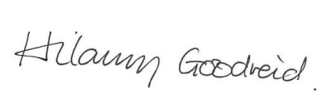
Resolutions (if any) from the floor

Town Clerk
Rugeley Town Council

